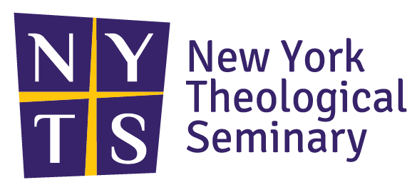

WINTERIM (January) 2023

Online Blackbaud Registration:
- Go to profile on Blackbaud
- Click on Class Enrollment
- Enter the class name or course code into the search box
- Click on appropriate course(s) and add to cart
- Click on finish enrolling when done
- Follow billing instructions
- Email: coevans@nyts.edu for billing questions
- Email: registrar@nyts.edu for registration questions

EMU2412: Sacred Response to Sexual Violence: A Transformative Theological & Educational Framework; 2 Cr.
Prof. Maritza Ortiz-Cruz dr.maritzaortizcruz@gmail.com
Dates: Jan 4, 9, 11, 18, 23, 24 (6:00 – 8:30 pm); Saturday Jan 7, 14, 21 (9 am - 5 pm)

The course will provide a historical examination on human sexuality informed by culture and society. It will explore social and religious ideologies and theologies that have historically influenced sexual attitudes in the public and domestic sphere of society. The course work will also examine the role of religion generally and the Christian church specifically as entities that sacredly respond to victims/survivors of sexual violence by offering shalom justice within a sacred transformative educational framework.

MRL2242: Practical Church Leadership in a Season of Crisis; 2 Cr.
Prof. Alfred Johnson, Dr. Pamela Stanley ajohnson@nyts.edu
Dates: (Tuesdays and Thursdays) January 3, 5, 10, 12, 17, 6:00pm – 8:30pm EST.
(Saturdays) January 7, 14, 8:30am – 3:30pm EST

This course will identify and describe the crisis of cultural shifts that affect all human organizations, and especially the church in the urban environment. We will review together several movements of change in our society and how they affect the very practical practices to which faith leaders must attend as they go about daily and special moments in the life of the church. We will cover the leadership competencies needed to be relevant and effective in such internal areas as: leading worship services, visitation ministries, administering the sacraments, receiving new members, managing aging buildings, etc. We will likewise explore such external issues, such as: gentrification, community organizations, social problems, etc. We will be a laboratory of learners, learning new concepts while pooling our experiences to create new paradigms of church leadership.

Personality Disorders, 2 Cr.
Date: Mon & Wed January 4, 9, 11, 18 (6:00 pm - 9:30 pm) & Sat. 7, 14 (8:30 am - 4:30 pm)
Prof: Insook Lee islee@nyts.edu

This course is designed to provide an in-depth approach to the understanding of personality disorders in adults. Topics to be addressed include historical considerations of personality disorders, clinical presentations, diagnostic challenges, epidemiology, patterns of comorbidity, theoretical models, assessment strategies, and intervention models. This course mostly focuses on Borderline, Narcissistic, Antisocial, and Histrionic personality disorders, but discusses other personality disorders as well. In addition, students will learn the diagnostic criteria for personality disorders as addressed in DSM-5 and examine representative treatment plans.

The Mind of the Spirit: Paul's Approach to Transformed Thinking
Date: Saturday, January 28, 2022 (Via Zoom: 9 AM – 4 PM) (The date is negotiable)
Credits: 1 Credit or 2 credits
Prof: Humberto Alfaro halfaro@nyts.edu

This course explores an important but neglected area of Pauline theology, Paul's teaching about the mind. Following the scholarly research of Craig S. Keener, we will discuss matters such as the corrupted mind, the mind of faith, the mind of the Spirit, the mind of Christ, a renewed mind, and the heavenly mind. We will analyze how Paul adapts language from popular intellectual thought in his day, but how he does so in a way distinctively focused on Christ and Christ's role in the believer's transformation. This course attempts to overcome a false separation between following the Spirit and using analytical inquiry and provides a foundation for relating critical analysis, spirituality, and ministry.

